Date:22/07/2024 **JAVA-CSA0983->TEST-3**

1.create array list and adding the element to the list lion ,tiger ,dogadding element at particular index and use for each to display all the element in array list .

Program:

public class Main {

public static void main(String[] args) {

java.util.ArrayList<String> animals = new java.util.ArrayList<>();

animals.add("Lion");

animals.add("Tiger");

animals.add("Dog");

animals.add(1, "Elephant");

for (String animal : animals) {

System.out.println(animal);

}

}

}

Output:

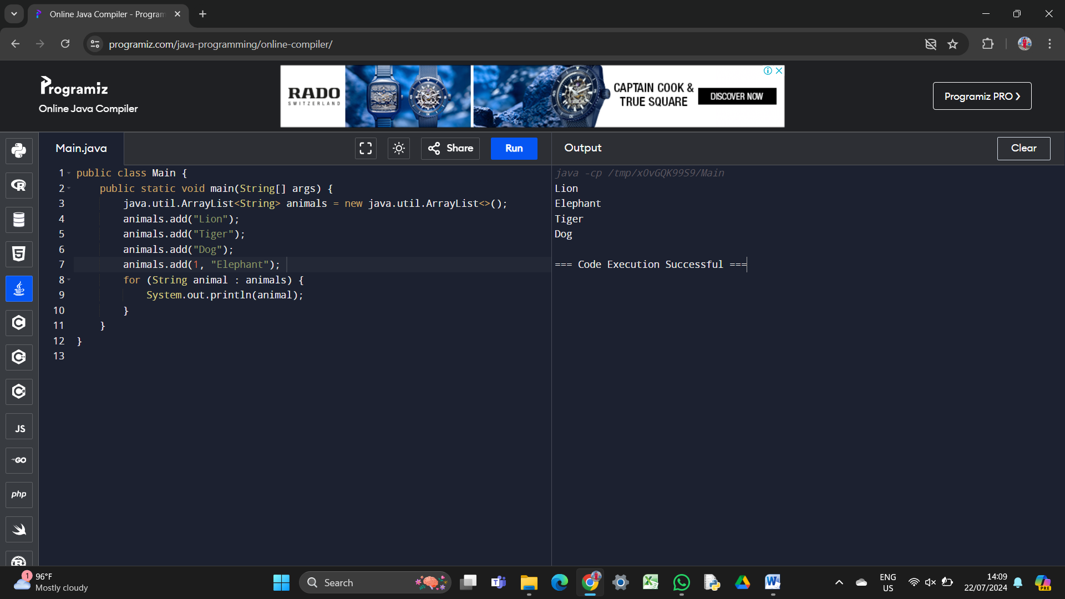

2.create array list insert number 2,4,5,6,8,9 and demonstrate size of array list demonstrate get method and set method .

Program:

import java.util.ArrayList;

public class Main {

public static void main(String[] args) {

ArrayList<Integer> numbers = new ArrayList<>();

numbers.add(2);

numbers.add(4);

numbers.add(5);

numbers.add(6);

numbers.add(8);

numbers.add(9);

System.out.println("Size of ArrayList: " + numbers.size());

System.out.println("Element at index 2: " + numbers.get(2));

numbers.set(3, 10);

System.out.println("Updated element at index 3: " + numbers.get(3)); }}

Output: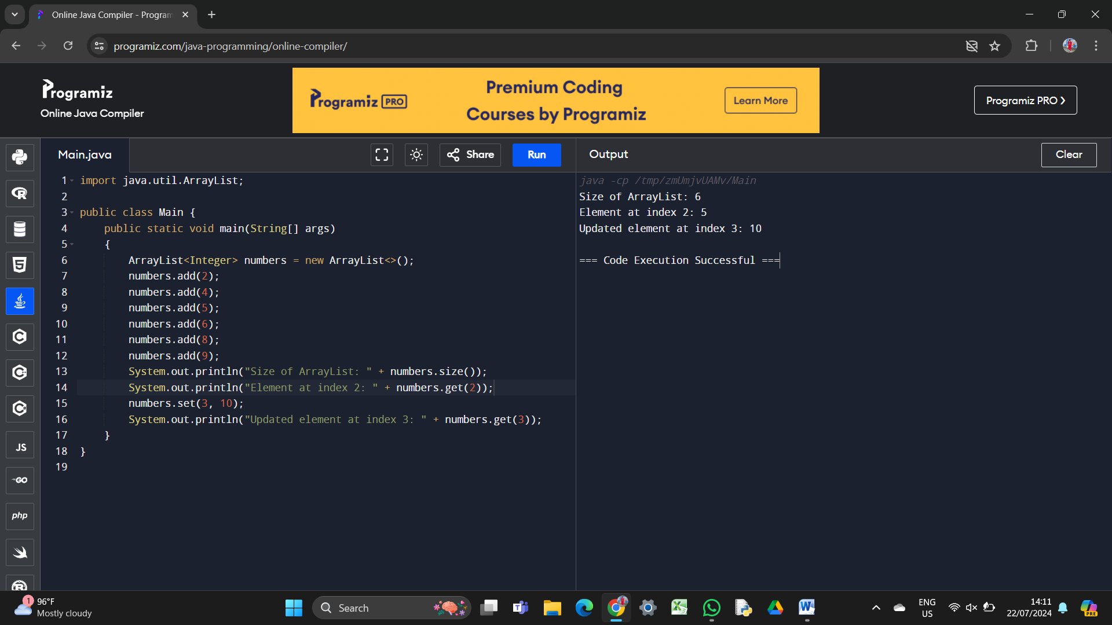

3.create the array list with element c ,c++,java, python, rubi, javascript demonstrate the following method

remove(index)

remove

remove all

Program:

import java.util.ArrayList;

public class ArrayListDemo {

public static void main(String[] args) {

ArrayList<String> programmingLanguages = new ArrayList<>();

programmingLanguages.add("C");

programmingLanguages.add("C++");

programmingLanguages.add("Java");

programmingLanguages.add("Python");

programmingLanguages.add("Rubi");

programmingLanguages.add("JavaScript");

System.out.println("Initial ArrayList: " + programmingLanguages);

programmingLanguages.remove(2);

System.out.println("After removing element at index 2: " + programmingLanguages);

programmingLanguages.remove("C++");

System.out.println("After removing first occurrence of C++: " + programmingLanguages);

programmingLanguages.clear();

programmingLanguages.add("Java");

programmingLanguages.add("Python");

System.out.println("After removing all elements that are not Java or Python: " + programmingLanguages);

}

}

Output:

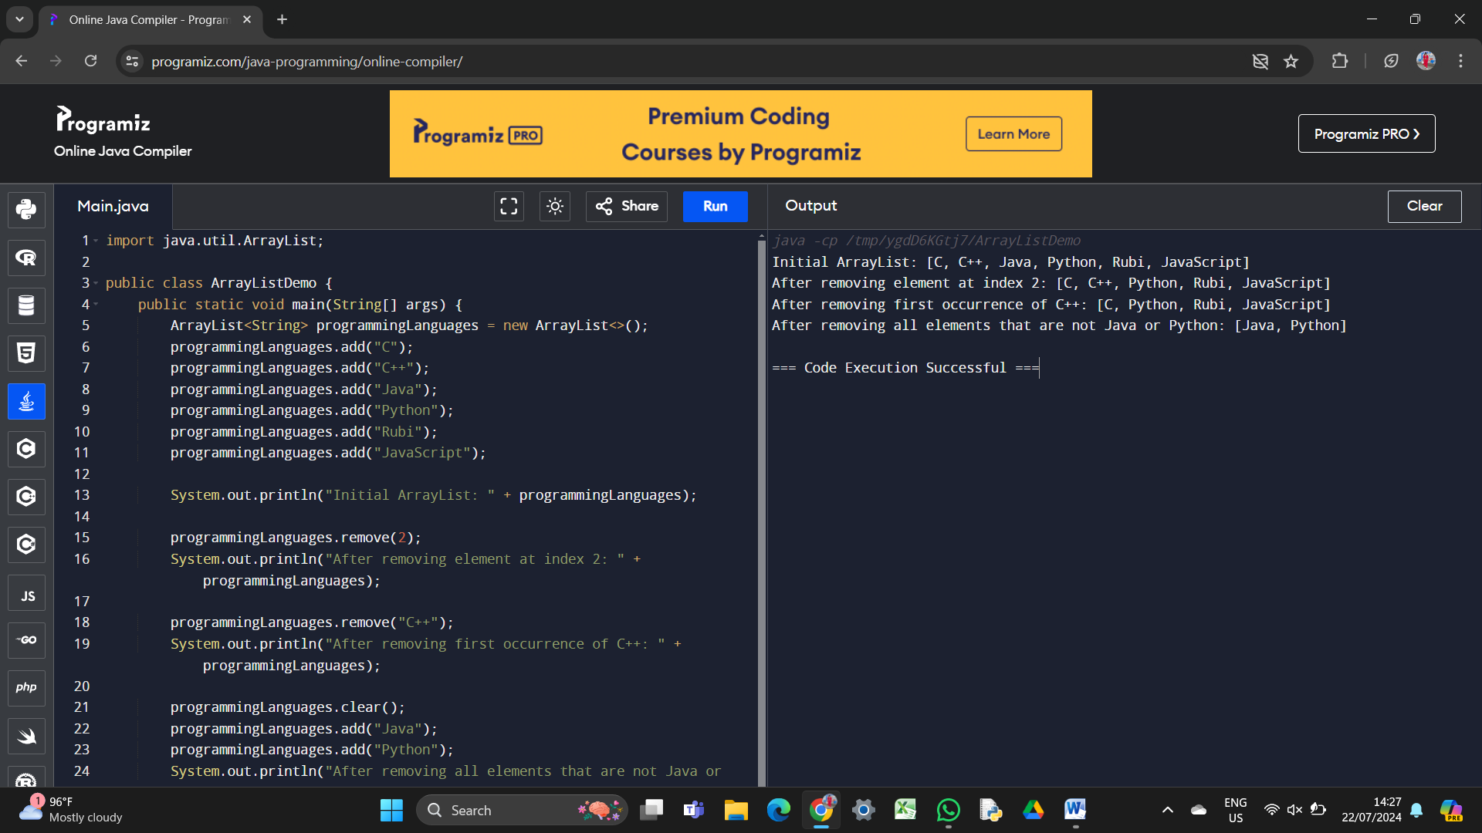

4. Create array list raja,ravi,ramu,vimal,roja demonstrate iterate over an array list using for each itertor ,list iterator.

Program:

import java.util.ArrayList;

import java.util.ListIterator;

public class ArrayListDemo {

public static void main(String[] args) {

ArrayList<String> names = new ArrayList<>();

names.add("RAJA");

names.add("RAVI");

names.add("RAMU");

names.add("VIMAL");

names.add("ROJA");

System.out.println("Iterating using for-each loop:");

for (String name : names) {

System.out.println(name);

}

System.out.println("Iterating using ListIterator:");

ListIterator<String> listIterator = names.listIterator();

while (listIterator.hasNext()) {

System.out.println(listIterator.next());

}

System.out.println("Iterating in reverse order using ListIterator:");

listIterator = names.listIterator(names.size());

while (listIterator.hasPrevious()) {

System.out.println(listIterator.previous());

       }

    }

}

Output:

